North Lincolnshire Council
Daily Event Analysis
16th January 2011

Overview

The Low Santon TEOM measured a daily mean PM₁₀ concentration of 66µg/m³ on Sunday 16th January 2011 exceeding the allowed 50µg/m³ as a daily mean. The Dawes Lane Coke Oven (DLCO) Osiris measured a daily mean concentration of 43µg/m³. A check of the data has revealed elevated concentrations of PM₁₀ between 07:30 and 14:30 at the Low Santon TEOM. During this period the Low Santon TEOM measured a mean concentration of 94µg/m³ and the DLCO Osiris 45µg/m³.
Met Conditions

Consistent South Westerly winds were recorded throughout the day. The wind within the 7 hour period of focus ranged between 215° and 226°. Wind speeds averaged at 3.7 m/s for the day.

Episode Wind Range
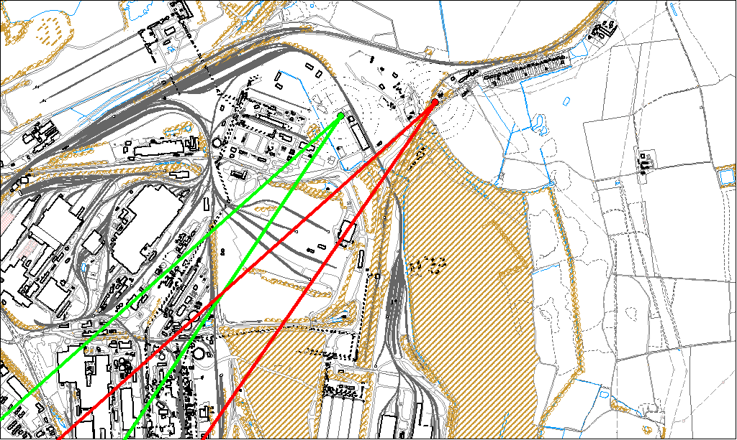

Potential Sources

The above map shows the Low Santon TEOM (indicated by the red lines) and the DLCO Osiris (indicated by the green). As only the Low Santon TEOM measured consistently higher concentrations during this period, it is likely that they were affected by a different source. Therefore, the area within the red lines is likely to contain the source.

The likely areas include;
- Redbourn site
- Intermediate site

